

Winter 2010

***Department of English***

***INKLINGS***



“The most durable thing in writing is style.”

--Raymond Chandler

**ENGLISH STUDENTS HOLD SECOND ANNUAL POP CULTURE CONFERENCE**

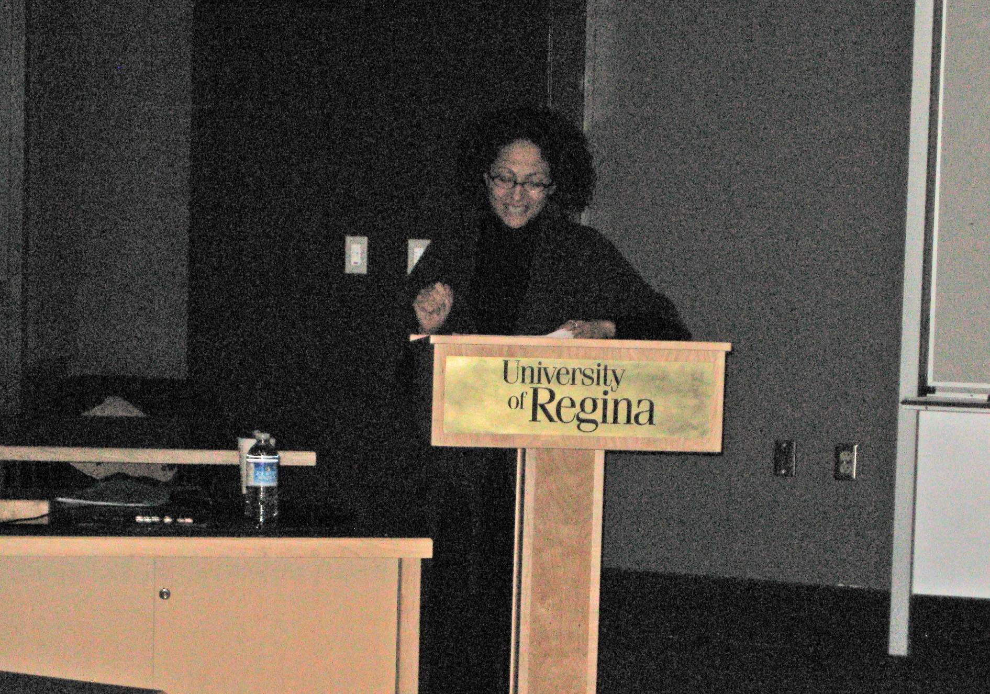

**Keynote Speaker, Dr. Stefania Forlini, University of Calgary, Addresses “Trash Talkin’” Delegates**

The second annual Trash Talkin': New Directions in Popular Culture and Creative Writing conference was held at the University of Regina on March 5th and 6th, 2010. Conceived by English Honours students Lauren Perchuk and Steve Hahn in the fall of 2008, and organized by students with the guidance of faculty, the conference gives students the opportunity to write academic papers on subjects not usually discussed in university classrooms. In addition to academic papers, Trash Talkin' also encourages students to submit creative writing and multimedia presentations.

Trash Talkin' 2010 featured papers from all corners of pop culture. Papers explored television series such as *Buffy the Vampire Slayer,* the cartoon series *Futurama,* comic books *The Watchmen* and *Captain America,* movies such as *Avatar,* video games, and science fiction and fantasy books. The conference was also noticeably interdisciplinary, welcoming presenters from the Departments of Philosophy, Fine Arts and Art History as well as presenters from other prairie universities.

Dr. Stefania Forlini from the University of Calgary was this year's keynote speaker, presenting a paper titled, “Steampunk's Time Machines: Future Past or Future Perfect?” Steampunk refers to a genre of science fiction set in the Victorian era in which steam-powered technology is coupled with elements of fantasy. Dr. Forlini's talk offered more than an introduction to the steampunk genre, and spurred discussion on the nature of material things in the Victorian age to an audience of about fifty.

In its mission to foster meaningful scholarly discussion and a sense of community within the student body, Trash Talkin' also featured a number of well-attended social events. [Space] Magazine, a student-run publication, hosted a successful open mic featuring the poetry and fiction of creative writing students, and the conference closed with a banquet at the University Club.

**Cassidy McFadzean**

**HEADNOTE**

**Serendipity**

Just recently, I had the pleasure of attending the HRI spring “Profiling Scholarship” session, which just happened to feature three of my English colleagues: Troni Grande gave a paper on her research focusing on the figure of Proserpina; Lynn Wells and Cindy Mackenzie both launched major book projects—Lynn a study of Ian McEwan, and Cindy a collection of essays on the letters of Emily Dickinson. This event was hosted at Campion College, and moderated by Chris Riegel, one of our English colleagues there. Listening to Troni’s paper, and to Lynn’s and Cindy’s descriptions of their projects, I was impressed by the repeated emphasis on collaboration, conversation, and community connection. I left the session energized and inspired yet again by the extraordinary group of people who find their academic home in the English department—both the diversity of their approaches and projects, and their connections with and respect for each other. The profiled scholars—including Sylvain Rheault, Sheila Petty, and Thomas Bredohl—also embody deep enduring commitment to the project of the humanities.

That is only a brief glimpse of the activity around here: Kathleen Wall published the Canadian edition of *Patterns for a Purpose: A Rhetorical Reader*, andhas been tirelessly committed to the rejuvenation of the *Wascana Review*. An online tutorial for first-year English is being launched this month—the fruit of Nils Clausson’s dedication and hard work over the past two years. In the same week, Susan Johnston gave a paper as part of the Archer Library’s “Beyond the Book” series. The second annual Trash Talkin’ conference on popular culture took place over the weekend, an excellent example of honours and graduate students’ taking a great idea and running with it. This week we will host Wendy Roy, from the University of Saskatchewan, as part of our annual exchange with their English department.

The story continues, beyond the campus and the degree, as students go on to take academic positions and pursue graduate work in other institutions. We often meet them later on as our colleagues. In reflecting on the past month, I am reminded of the importance of spending at least one hour per week talking with a colleague and/or student about his or her work and life. It seems particularly necessary to celebrate the serendipity of our encounters as we huddle down to these last, draining weeks of the semester; it’s easy to get mired in the frustrating aspects of our academic work. Stay tuned and stay open to serendipity: it’s not the end of the story.

**Dorothy Lane**, Department Head

**JOANNE PEDERSON, ENGLISH DEPARTMENT SECRETARY, RETIRES**

In December of 2008, Joanne Pederson retired, after almost 30 years as secretary to the English Department Head. In that time, countless students, colleagues, Heads, Deans, Presidents and Vice-Presidents came and went, but almost every morning Joanne was at her desk. She joined us in 1979, after 5 years in the Registrar’s office. She served under, trained and survived 10 heads of department: Chris Murray, Martin Bergbusch, Ray Mise, Bill Howard, Ken Probert, Ken Mitchell, Peggy Wigmore, Cameron Louis, Jeanne Shami, and Dorothy Lane. She also outlasted countless colleagues, students, typewriters, computers, Gestetners, photocopiers, and printers. Indeed, Joanne handled her duties all these years with efficiency and a great sense of responsibility. She often bemoaned the fact that most university deadlines were made for departments half our size, but the fact that we never seemed to miss them is more a credit to her than anyone else. And through all the trials and tribulations in that office she maintained a cheerful demeanour and always greeted colleagues and students with care and civility. All of us would like to give Joanne a big thank you and wish her good luck and a long and healthy and active retirement.

**Cameron Louis**

**WINTER OMAD PROGRAM**

The Winter 2010 OMAD Program is as follows:

**Friday, January 22:**

**Dr. Nils Clausson , Department of English**

“Clarity, George Orwell, and the Pedagogy of Prose Style; or, How Not to Teach ‘Shooting an Elephant’”.

**Friday, February 5: (CANCELLED)**

**Dr. Michael Trussler, Department of English**

Recent work from *A Homemade Life*.

**Friday, March 19:**

**Dr. William Arnal, Religious Studies**

“Discordant Metaphors in the Gospel of Thomas: Language as a Model of the Cosmos

**Bev Montague** and **Marcel DeCoste**

OMAD co-ordinators

**SPEAKERS’ EXCHANGE PROGRAM**

On March 12, as part of the Department of English Speakers’ Exchange Program with the University of Saskatchewan, Dr. Wendy Roy, from the U. of S., gave a lecture entitled “Playing Back Canada to Canadians: Literary Nationalism in Early Twentieth-Century Canadian Popular Fiction.” Her paper explored the way that Canada has historically been imagined through works of popular culture, which are then reimagined outside Canada and “played back” to Canadians as these works are published, adopted and adapted as part of other national cultures.

**NEWS OF FACULTY**

**Brenda Beckman-Long** received her PhD in English from the University of Alberta last June, and she recently published "Nationalism and Gender: The Reception of Laurence's *The Diviners*" in *West of Eden: Essays on Canadian Prairie Literature*, edited by Sue Sorensen.

**Nils Clausson** published “‘A Scrupulous Unity of Tone’: Irony, Narrative Focus, and the Representation of Africa(ns) in Conrad’s “An Outpost of Progress” in *The CEA Critic* 71.3 (Spring & Summer 2009): 85-99; and “Oscar Wilde Our Contemporary,” a review of *Approaches to Teaching the Works of Oscar Wilde* (MLA, 2008), in *Papers on Language and Literature* 46.1 (Winter 2010): 93-101. The project for which he received a TEL grant, the creation of an online writing tutorial for students in English 100 and 110, has been completed. The site was previewed on March 4 and is now up and running. In January Nils contributed to the English Department’s OMAD series with a paper entitled “Clarity, George Orwell, and the Pedagogy of Prose Style; or, How Not to Teach ‘Shooting an Elephant.’”

**Marcel DeCoste** presented a paper entitled, “Founded on Fact: Faith and Reason against Modernity in the Hagiographies of Evelyn Waugh,” to the 3rd Annual Baylor Symposium on Faith and Culture at Baylor University, Waco, Texas, October 9, 2009. His essay/entry (2965 words) on "Fiction of World War Two” will soon be appearing in the Wiley-Blackwell *Encyclopedia of Twentieth-Century Fiction*, edited by Brian Shaffer, slated for publication this summer. He is presently at work on an essay on celebrity, modernism and impersonal aesthetics in Evelyn Waugh's 1930 novel, *Vile Bodies*.

**Jo-Ann Episkenew** was the Principal Applicant on a successful application for a CIHR Operating Grant of $357,842 for a research project titled *Development of Aboriginal Youth Health Leadership Through Theatre*. She also was appointed Director of the Indigenous Peoples' Health Research Centre, effective January 1, 2010.

**Cindy MacKenzie** participated in the Humanities Research Institute’s Winter/Spring Profiling Scholars Symposium, launching her book *Reading Dickinson’s Letters: Critical Essays*, co-edited with Jane Donahue Eberwein, published by University of Massachusetts Press in December 2009. She will present her own essay in the collection, “This is my letter to the world”: Dickinson’s Epistolary Poetics” at the American Literature Association in San Francisco in May. She also gave a talk, “The Art within the Soul: Emily Dickinson’s Private Religion” for the Unitarian Fellowship of Regina, where the full-size cardboard cut-out of the poet made as much of an impact as the talk. This summer, the Emily Dickinson International Society meets at Keble College in Oxford, England, where Cindy will give a paper, “Essential Oils: The Shakespearean Sonnet and Dickinson’s Poetic.”

**Jeanne Shami** recently published “Donne and the Bible” in *The Blackwell Companion to Literature and the Bible*. Ed. Rebecca Lemon, Emma Mason, Jonathan Roberts, Christopher Rowland (Oxford: Blackwell, 2009): 240-53. She also edited a volume on Renaissance tropes entitled *Renaissance Tropologies: The Cultural Imagination of Early Modern England* (Pittsburgh: Duquesne UP, 2008), which includes her introduction as well as an her essay “Troping Religious Identity: Circumcision and Transubstantiation in Donne’s Sermons” (pp. 89-117). This volume was supported by an HRI publication subvention. Her essay analyzing the significance of two new manuscripts containing sermons by John Donne, entitled “New Manuscript Texts of Sermons by John Donne,” was published in *English Manuscript Studies* 13 (2008): 77-119. Her review of Novik’s novel *Conceit*, loosely based on John Donne’s life, appeared in *Wascana Review* 41.1-2 (2006): 131-38 [published in 2008]. In 2008, she reviewed the Modern Languages Department of King’s University College, University of Western Ontario, and in 2009 served on the national SSHRCC Standard Research Grant adjudication committee. Additionally, two of her students – Jaime McGrane and Mathew Block – have completed Honours papers. She is in her final year as Faculty Representative to the University’s Board of Governors.

**Michael Trussler** has published *A Homemade Life* (Saskatoon: JackPine Press, 2009). It's an "experimental" Chapbook . . . a mixture of photographic images, prose pieces, and verse--all done in a package that resembles a box of greeting cards.

**Kathleen Wall** published the Canadian Adaptation of Barbara Fine Clouse's *Patterns for a Purpose* with McGraw Hill. This is a rhetoric and reader designed for writing-intensive classes. Departments that have adopted the text have been particularly excited by the strategies for teaching argument and persuasion, and the generous number of essays on climate change.

**Lynn Wells**’ book *Ian McEwan* was released in January 2010 by Palgrave Macmillan UK. In February she spoke about her research for and writing of the book at the Humanities Research Institute’s Winter/Spring Profiling Scholars Symposium.

**REPORT FROM THE CO-ORDINATOR OF FIRST-YEAR ENGLISH**

In August of 2009, the Department held a very successful day-long professional development workshop, “Introduction to Teaching English 100,” with sessions on such matters as Rights and Responsibilities of Instructors, the changing demographics of the first year classroom, diverse learning styles, and syllabus writing. Attendees received a certificate; this August, we will follow up with an advanced session which addresses teaching research writing in the first year as well as strategies for developing student reading skills.

We will be holding a one-day retreat in May on changing writing issues in the first-year classroom; all instructors of first-year English are invited to attend this brainstorming session, as we work together to identify shifting patterns in our students’ writing and develop teaching units and assignments to address these issues.

We are also pleased to announce the launch, in late March of this year, of the Department of English’s Online Writing Tutorial, developed by Dr. Nils Clausson. This web site will be accessible directly and from the English Department home page. Other activities have included the exploration of interactive digital tools for supporting student writing.

**Susan Johnston**

**NEWS OF GRADUATES**

The Johnson-Shoyama Graduate School of Public Policy at the University of Regina has announced the results of its 7th Annual Student Public Policy Essay Contest. The Graduate Winner is **Andrea Ulrich**, with an essay entitled “The Road to a Greener Fleet: An Economic Analysis of the Government of Saskatchewan’s Environmental Vehicle Policy.” Andrea earned both her Bachelor of Arts and her Master of Arts Degrees in English from the University of Regina. Congratulations, Andrea!

News to be included in the next issue of *Inklings* is due **October 8, 2010.**

**PLEASE FORWARD YOUR NEWS TO:**

Nils Clausson, Editor

[Nils.Clausson@uregina.ca](mailto:Nils.Clausson@uregina.ca)

***INKLINGS***

Department of English

University of Regina

Regina, SK S4S 0A2